WEBSITE INTERFACE DEMONSTRATION

HOME PAGE

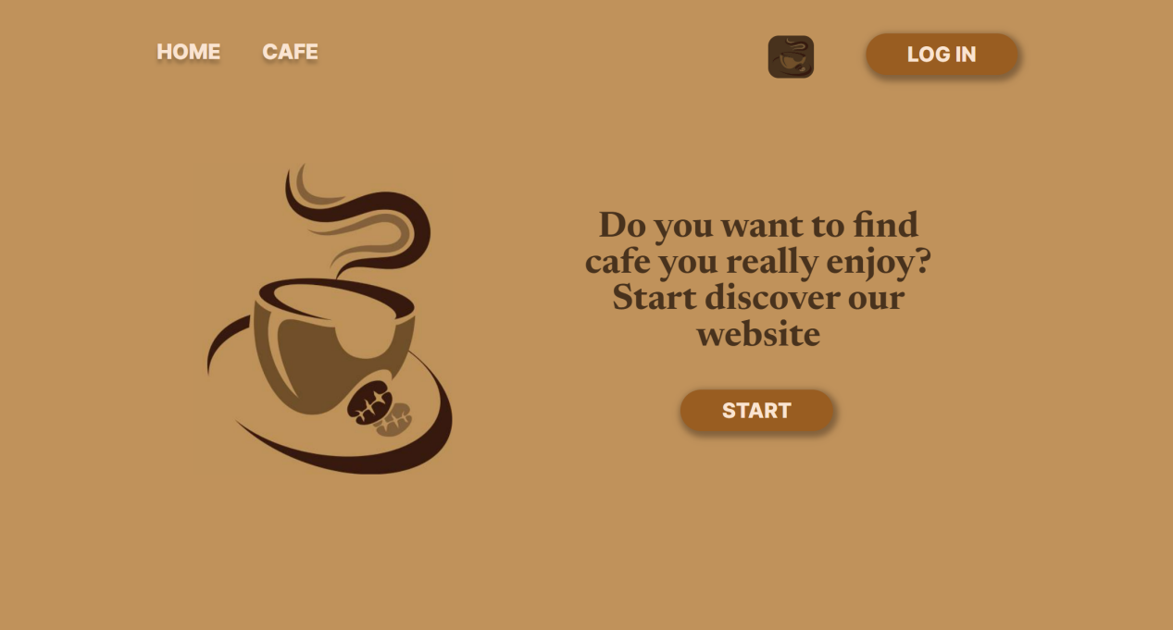

IF YOU CLICK ON THE “HOME” BUTTON, YOU WILL BE REDIRECTED TO THE SAME PAGE(HOME).



IF YOU CLICK ON THE “CAFE” BUTTON, YOU WILL BE REDIRECTED TO THE CAFE PAGE.



IF YOU CLICK ON THE “LOG IN” BUTTON, YOU WILL BE REDIRECTED TO THE LOGIN PAGE.



IF YOU CLICK ON THE THEME CHANGER BUTTON, THE VIEW OF THE WEBSITE WILL BE CHANGED.



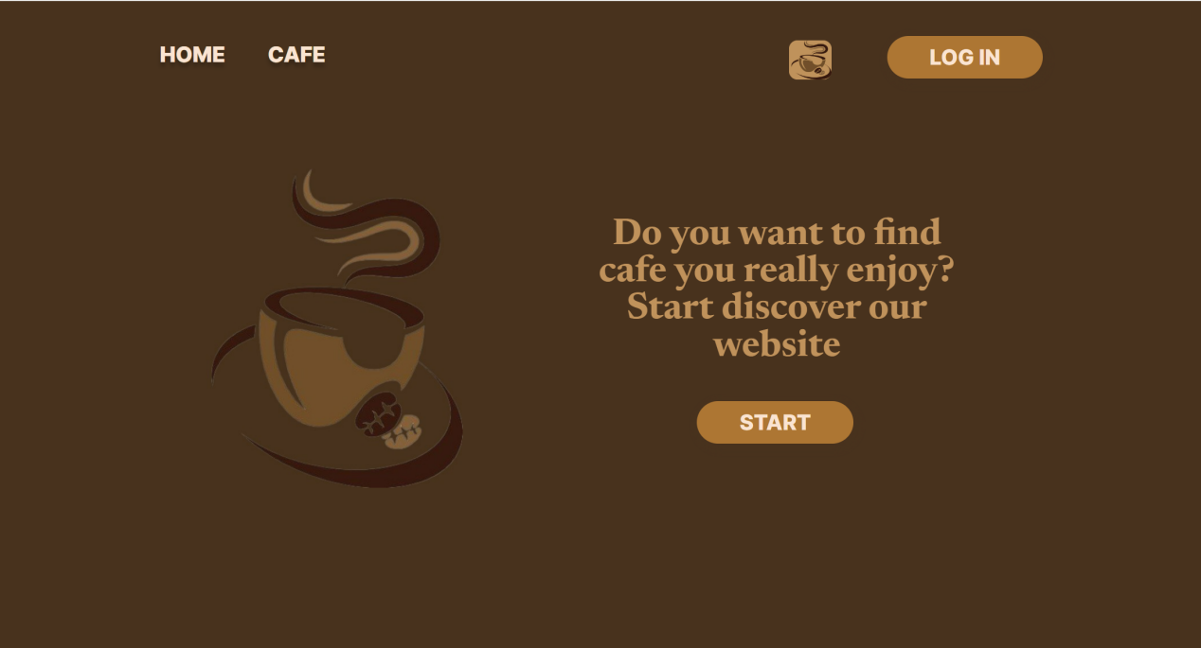

IF YOU CLICK ON THE START BUTTON ON THE HOME PAGE,



YOU WILL BE DROPPED TO THE LIST OF THREE CAFES.

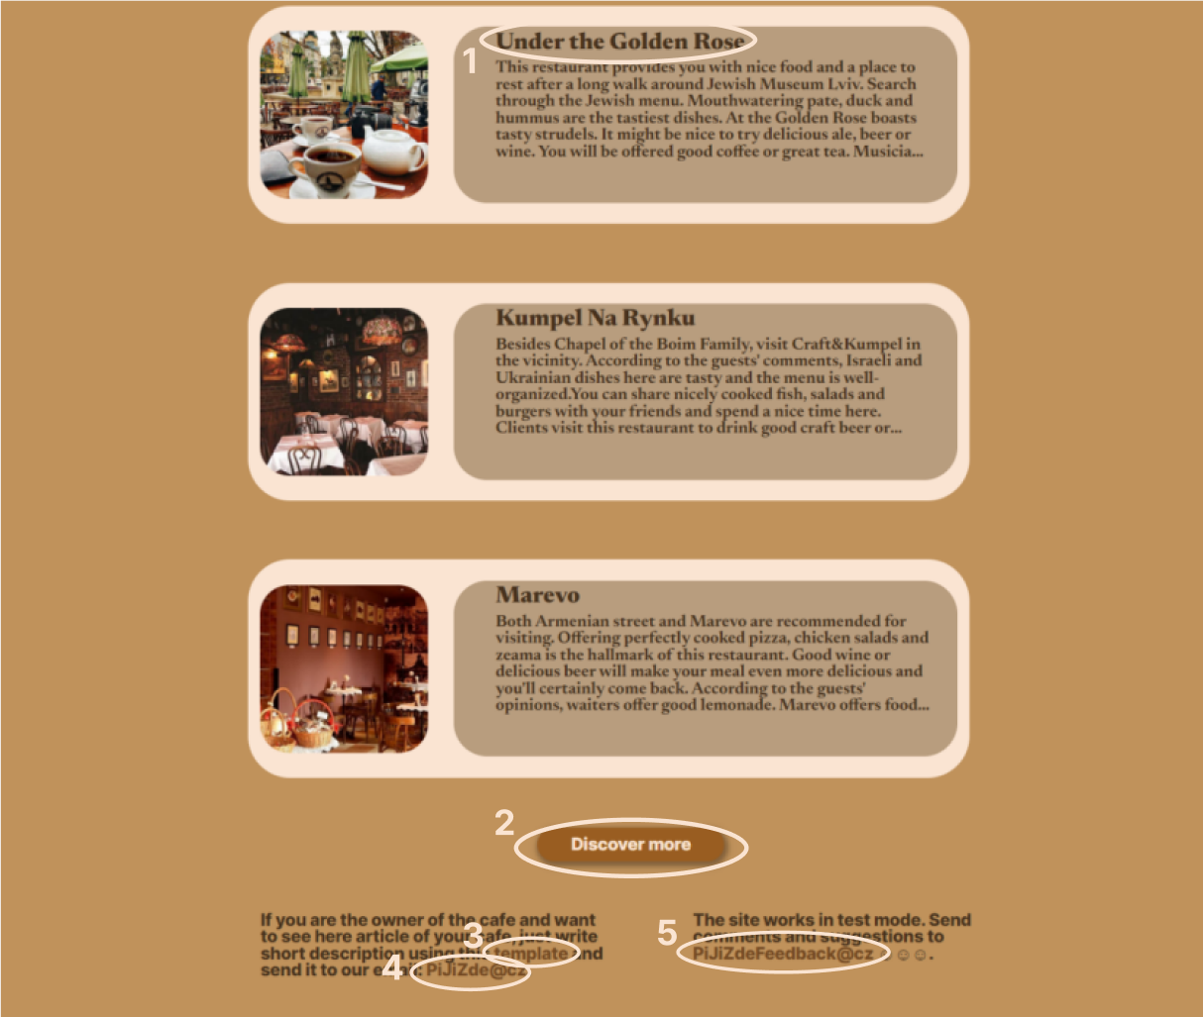

HERE YOU CAN DO:

1. GO TO THE PAGE OF THE CAFE.
2. CLICK ON THE BUTTON “DISCOVER MORE” AND REDIRECTED TO THE CAFE PAGE.
3. DOWNLOAD THE TEMPLATE OF CAFE DESCRIPTION BY CLICKING ON THE “template”.
4. SEND THE TEMPLATE TO THE EMAIL BY CLICKING “PiJiZde@cz”.
5. SEND YOUR SUGGESTIONS TO THE EMAIL “PiJiZdeFeedback@cz”.

LOGIN PAGE

IF YOU ENTERED SOMETHING INCORRECTLY, THE FIELDS WOULD TURN ORANGE AND AN ERROR WILL HAPPENED.

IF YOU CLICK THE BUTTON “*CONTINUE*”, YOU WILL BE REDIRECTED TO THE HOME PAGE AND TH ELOGIN BUTTON WILL BE CHANGED INTO “LOGGED OUT” ONE, IN THE CASE OF SUCCESSFUL LOGIN.

IF YOU DON’T HAVE AN ACCOUNT, YOU CAN SIMPLY CLICK ON THE LINK ”*DON’T HAVE AN ACCOUNT? CREATE ACCOUNT*” AND YOU WILL BE REDIRECTED TO THE REGISTATION FORM.

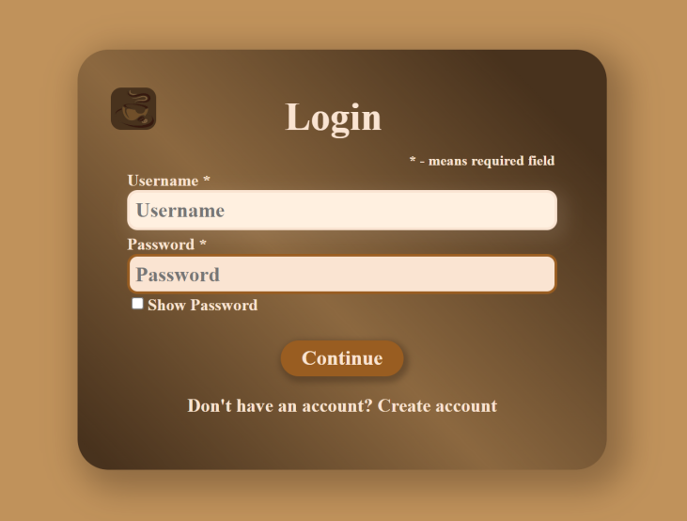  

REGISTRATION PAGE 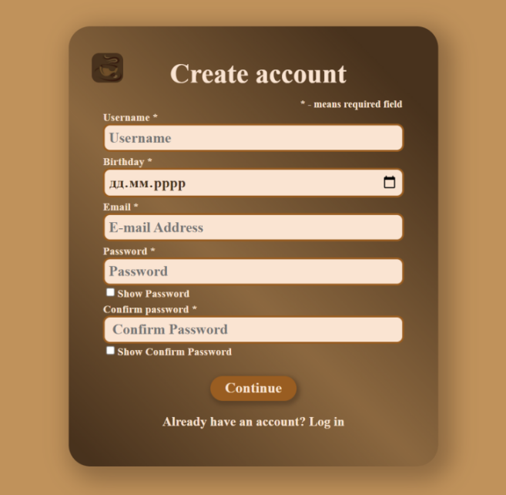

ALL FIELDS ARE REQUIRED. BIRTHDAY IS IN THE RANGE OF(01.01.1920; TODAY).

IF YOU ENTERED SOMETHING INCORRECTLY, THE FIELDS WOULD TURN ORANGE AND AN ERROR WILL HAPPENED.

IF YOU CLICK THE BUTTON “*CONTINUE*”, YOU WILL BE REDIRECTED TO THE LOGIN PAGE, IN THE CASE OF SUCCESSFUL REGISTRATION.

IF YOU ALREADY HAVE AN ACCOUNT, YOU CAN SIMPLY CLICK ON THE LINK ”ALREADY HAVE AN ACCOUNT? LOG IN” AND YOU WILL BE REDIRECTED TO THE LOGIN FORM, WHERE YOU NEED TO WRITE USERNAME AND PASSWORD, WHICH YOU HAVE WRITTEN ON THE REGISTRATION FORM.

CAFE PAGE

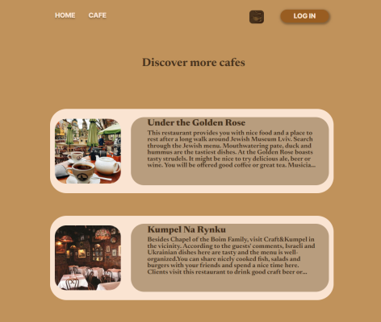

HERE IS THE CAFE PAGE. THE NAVIGATION MENU IS THE SAME AS IN THE HOME PAGE.

IF YOU CLICKED ON THESE TITLE OF THE CAFES, YOU WILL BE REDIRECTED TO THE A PAGE OF THE SEPARATED CAFE(SEE BELOW)…..IF YOU ARE LOGGED IN, YOU CAN WRITE COMMENTS AND DELETE THEM ON THE CAFE PAGE.

BUTTONS WITH NUMBERS INDICATE THE TRANSITION THROUGH THE PAGES.

THIS MEANS IF YOU CLICK ON ANY OF THE BUTTONS, YOU WILL BE REDIRECTED TO THE PROPER PAGE.

ON EACH PAGE ARE THREE CAFES. SO FOR INSTANCE IF ON THE WEBSITE WILL BE 4 PAGES, IT MEANS YOU CAN DISCOVER 12 CAFES.

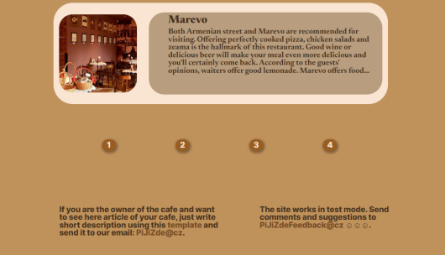

SEPARATED CAFE

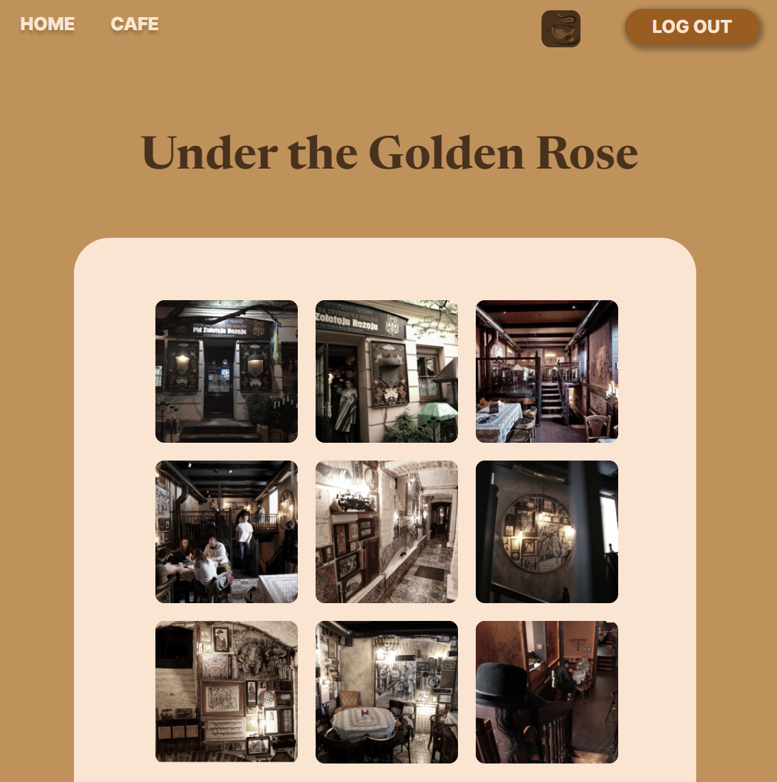

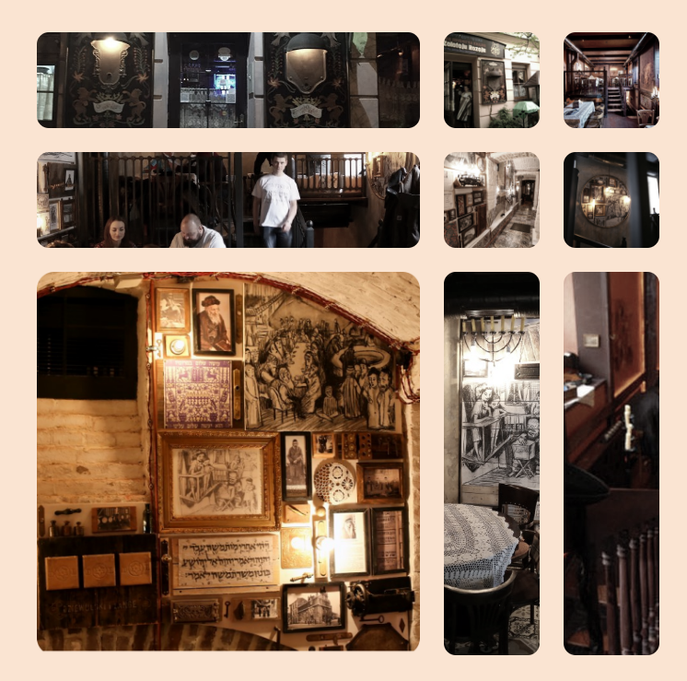 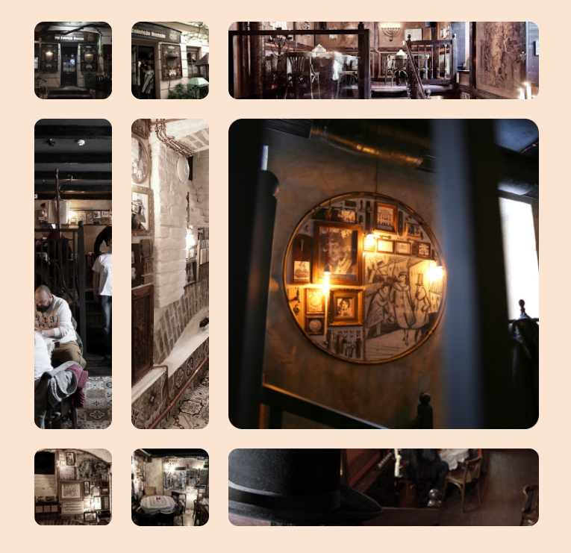

IF YOU HOVER OVER ANY PHOTO, IT WILL BE INCRESED AND BRIGHTEN.

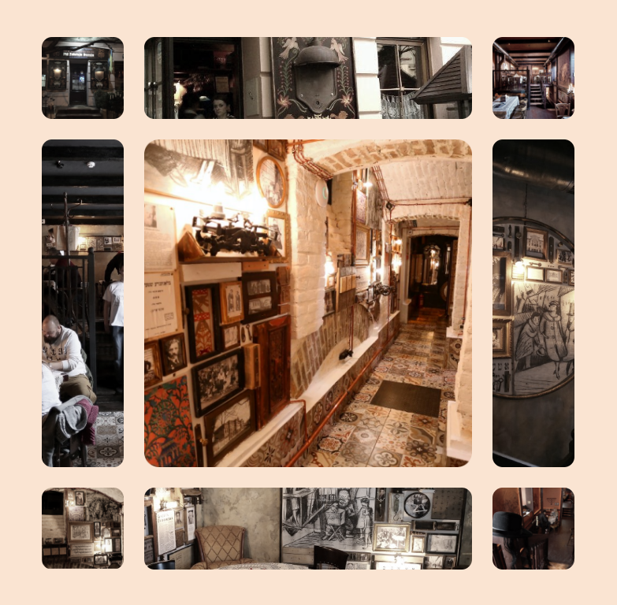 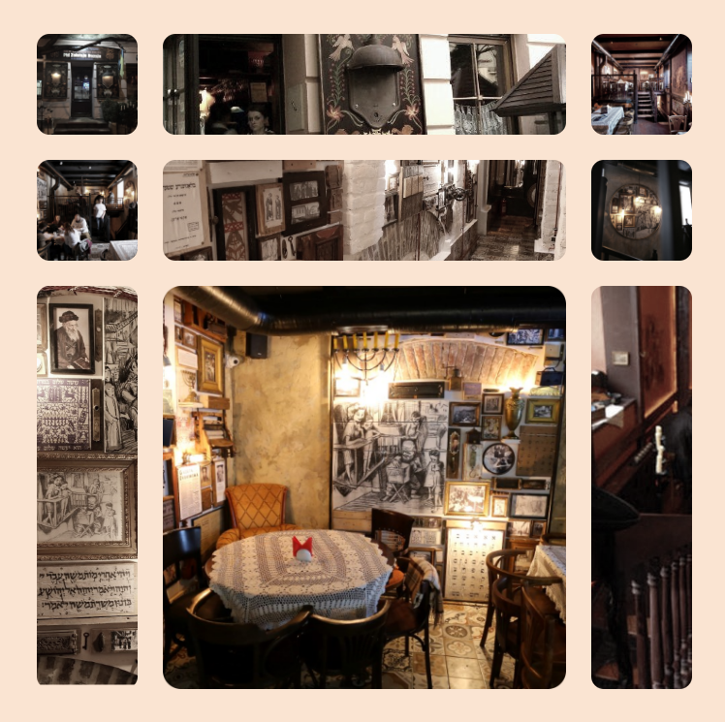

HERE IS ONE OF THE CAFES. ON THIS PAGE YOU CAN FIND MORE INFORMATION ABOUT THE CAFE.

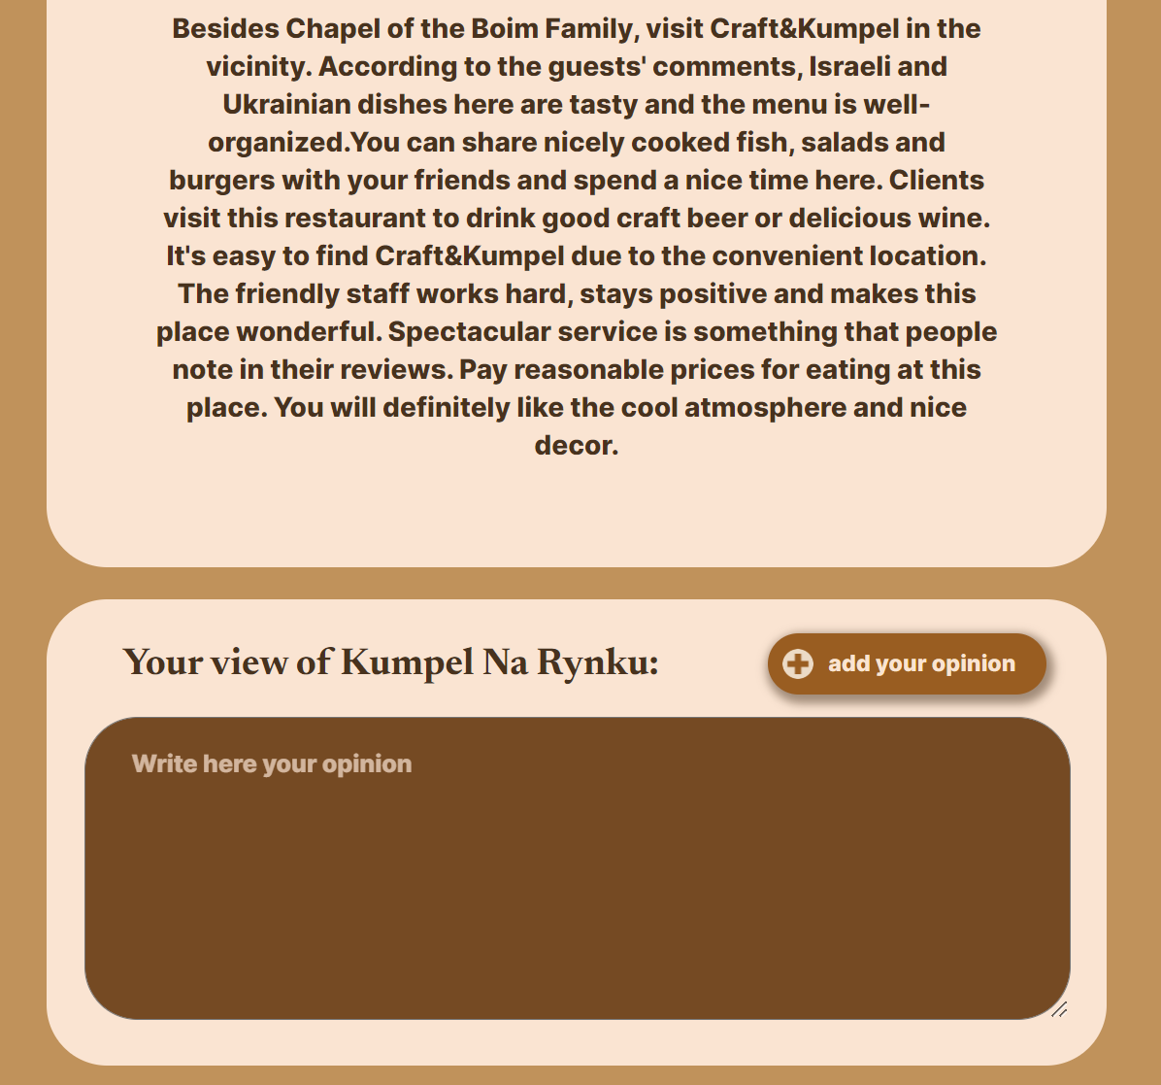

IF YOU SCROLLED DOWN, YOU CAN SEE THE RECENZE ON THE CAFE AND IF YOU ARE LOGGED IN, YOU CAN WRITE YOUR OPINION OF THE CAFE I THIS FORM. IN ORDER TO PUBLISH THE COMMENT YOU NEED TO CLICK ON THE BUTTON” ADD YOUR OPINION”.

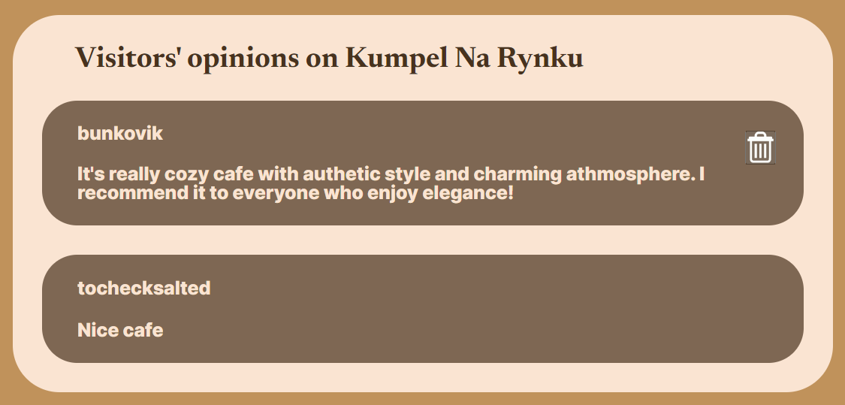

IF YOU DIDN’T LOGGED IN, YOU CAN JUST READ THE OTHER VISITOR’S COMMENTS. IF YOU ARE ALREADY LOGGED IN AND WRITE A COMMENT, YOUR COMMENT WILL BE PUBLISHED HERE AND YOU CAN DELETE IT, BUT YOU CAN DELETE ONLY YOUR COMMENT NOT OTHER USERS ONES.